Adapting wheat in Europe for climate change

M. A. Semenovª, P. Stratonovitchª, F. Alghabari^{b}, M. J. Gooding^{b,*}

ªComputational and Systems Biology Department, Rothamsted Research, Harpenden, Herts, AL5 2JQ, UK
^{b}School of Agriculture, Policy and Development, University of Reading, Earley Gate, P.O.
Box 237, Reading RG6 6AR, UK

*Corresponding author: Tel: +44 118 378 8487; fax +44 118 935 2421.
Email address: m.j.gooding@reading.ac.uk

Keywords:
wheat ideotype
crop improvement
heat and drought tolerance
crop modelling
impact assessment
Sirius

Abbreviations:
A = maximum area of flag leaf area; ABA = abscisic acid; CV = coefficient of variation; FC = field capacity; Gf = grain filling duration; GMT = Greenwich mean time; GS = growth stage; HSP = heat shock protein; LAI = leaf area index; HI = harvest index; Ph = phylochron; Pp = photoperiod response; Ru = root water uptake; S = duration of leaf senescence; SF = drought stress factor

Word count: 10418
Tables: 3
Figures: 8 (1 colour)
ABSTRACT
Increasing cereal yield is needed to meet the projected increased demand for world food supply of about 70% by 2050. Sirius, a process-based model for wheat, was used to estimate yield potential for wheat ideotypes optimized for future climatic projections (HadCM3 global climate model) for ten wheat growing areas of Europe. It was predicted that the detrimental effect of drought stress on yield would be decreased due to enhanced tailoring of phenology to future weather patterns, and due to genetic improvements in the response of photosynthesis and green leaf duration to water shortage. Yield advances could be made through extending maturation and thereby improve resource capture and partitioning. However the model predicted an increase in frequency of heat stress at meiosis and anthesis. Controlled environment experiments quantify the effects of heat and drought at booting and flowering on grain numbers and potential grain size. A current adaptation of wheat to areas of Europe with hotter and drier summers is a quicker maturation which helps to escape from excessive stress, but results in lower yields. To increase yield potential and to respond to climate change, increased tolerance to heat and drought stress should remain priorities for the genetic improvement of wheat.

- Introduction
Food security has become a major challenge given the projected need to increase world food supply by about 70% by 2050 (Anon., 2009). Considering the limitations on expanding crop-growing areas, a significant increase in crop productivity will be required to achieve this target (Parry et al., 2011; Reynolds et al., 2011). Wheat production is highly sensitive to climatic and environmental variations (Porter and Semenov, 2005). Global warming is characterised by shifts in weather patterns and increase in frequency and magnitude of extreme events (Lobell et al., 2012; Semenov and Shewry, 2011; Sillmann and Roeckner, 2008). Increasing temperature and incidence of drought associated with global warming are posing serious threats to food security (Lobell et al., 2013). Climate change, therefore, represents a considerable challenge in achieving the 70%-increase target in world food production. New wheat cultivars better adapted for future climatic conditions will therefore be required. However, the intrinsic uncertainty of climate change predictions poses a challenge to plant breeders and crop scientists who have limited time and resources and must select the most appropriate traits for improvement (Foulkes et al., 2011; Semenov and Halford, 2009; Zheng et al., 2012). Modelling provides a rational framework to design and test in silico new wheat ideotypes optimised for target environments and future climatic conditions (Hammer et al., 2006; Hammer et al., 2010; Semenov and Halford, 2009; Semenov and Shewry, 2011; Sylvester-Bradley et al., 2012; Tardieu and Tuberosa, 2010; Zheng et al., 2012). Eco-physiological process-based crop models are commonly used in basic and applied research in the plant sciences and in natural resource management (Hammer et al., 2002; Passioura, 1996; Rötter et al., 2011; Sinclair and Seligman, 1996; White et al., 2011). They provide the best-available framework for integrating our understanding of complex plant processes and their responses to climate and environment. Such models are playing an increasing role in guiding the direction of fundamental research by providing quantitative predictions and highlighting gaps in our knowledge (Hammer et al., 2006; Hammer, et al., 2010; Semenov and Halford, 2009; Semenov and Shewry, 2011; Tardieu, 2003).
The objective of our study was to assess wheat yield potential under climate change in Europe and identify challenges which must be overcome to achieve high wheat yields in the future. Firstly, we used the Sirius wheat model to optimise wheat ideotypes for future climate scenarios (Jamieson and Semenov, 2000; Lawless et al., 2005; Semenov, 2009; Semenov and Stratonovitch, 2013). А wheat ideotype was defined as a set of Sirius cultivar parameters. By changing cultivar parameters, we change wheat growth and development in response to climatic and environment variations and can select ideotypes with better performance under future climates and environments. Sirius is a well validated model and was able to simulate accurately wheat growth and grain yield in a wide range of environments, including Europe, USA, New Zealand and Australia, and for experiments reproducing conditions of climate change, e.g. Free-Air Carbon dioxide Enrichment (FACE) experiments (Ewert et al., 2002; He et al., 2012; Jamieson et al., 2000; Lawless et al., 2008; Martre et al., 2006; Asseng et al., 2013).
Despite the current utility of Sirius, it remains a challenge for such models to capture the yield response of wheat to extreme events, particularly when they coincide with sensitive growth stages (Craufurd et al. 2013). Crop models need an overhaul to incorporate such responses to extreme weather events (Rötter et al., 2011). For example, it has been established that wheat yield is particularly sensitive to abiotic stresses during microsporogenesis, anther dehiscence and fertilization because of effects on grain set (as reviewed by Barnabas et al., 2008; Craufurd et al. 2013); and just after fertilization because of effects on grain size (Gooding et al. 2003). To facilitate model development additional data from carefully designed experiments will be required. The second approach presented here is, therefore, to describe the response of wheat to heat and drought stress as imposed at booting and anthesis, using pot-grown plants and controlled environment facilities.

- Assessing yield potential of future wheat ideotypes
We selected ten sites for our study representing wheat growing regions in Europe (Table 1). Wheat ideotypes were described by nine model parameters used in the Sirius wheat model to describe wheat cultivars and considered as most promising for improvement of yield potential under climate change (Table 2). We used an evolutionary algorithm to optimize ideotypes for future climatic conditions as predicted by the HadCM3 global climate model.

  - Cultivar parameter space for optimisation
The ranges of parameters values used in optimization are presented in Table 2. The ranges were based on parameters calibrated by Sirius for modern cultivars allowing for variations reported in the literature for existing wheat germplasm (He et al., 2012; Semenov et al., 2009).
Photosynthesis. We assume that a 10% increase in light conversion efficiency could be achieved in the future. Using a model of canopy photosynthesis, (Tambussi et al., 2007) showed that the value of parameter λ (Rubisco specificity factor that represents the discrimination between CO₂ and O₂) found in current C3 crops exceeds the level that would be optimal for the present CO₂ concentration ([CO₂]), but would be optimal for [CO₂] of about 220 ppm, the average over the last 400,000 years. The simulation results showed that up to 10% more carbon could be assimilated, if λ was optimal for the current [CO2] level.
In Sirius, radiation use efficiency (RUE) is proportional to [CO₂] with an increase of 30% for doubling in [CO₂] compared with the baseline of 338 ppm, which is in agreement with the recent meta-analysis of field-scale experiments on the effects of [CO₂] on crops (Vanuytrecht et al., 2012). A similar response was used by other wheat simulation models, e.g. CERES (Jamieson et al., 2000) and EPIC (Tubiello et al., 2000).
Phenology. Three cultivar parameters are directly related to phenological development of wheat, i.e. phylochron Ph, daylength response Pp and duration of grain filling Gf (Table 2). Modifying the duration and timing of crop growth cycle in relation to seasonal variations of solar radiation and water availability may have significant effects on yield (Akkaya et al., 2006; Richards, 2006). An optimal flowering time has been the single most important factor to maximise yield in dry environments (Richards, 1991). The phyllochron Ph is the thermal time required for the appearance of successive leaves, and is a major driver of phenological development (Jamieson et al., 1995; Jamieson et al., 2007; Jamieson et al., 1998a). Details of the response of final leaf number to daylength Pp could be found in (Brooking et al., 1995; Jamieson et al., 1998b). By modifying phyllochron Ph and daylength response Pp we alter the rate of crop development and, therefore, the date of flowering and maturity. Increasing the duration of the grain filling period Gf has been suggested as a possible trait for increasing grain yield in wheat (Evans and Fischer, 1999). In Sirius, Gf is defined as a cultivar-specific amount of thermal time which needs to be accumulated to complete grain filling (Jamieson et al., 1998b). During grain filling, assimilates for the grain are available from two sources: new biomass produced from intercepted radiation and water-soluble carbohydrates stored mostly in the stem before anthesis. In Sirius, the labile carbohydrate pool is calculated as a fixed 25% of biomass at anthesis, and is translocated to the grain during grain filling. Increasing Gf will increase the amount of radiation intercepted by the crop and, consequently, grain yield. However, in the model, water-soluble carbohydrates accumulated before anthesis are transferred into the grain at a rate inversely proportional to Gf. Therefore, any increase of Gf will also reduce the rate of biomass remobilisation. Under stress conditions, when grain growth could be terminated as a results of leaves dying early due to water or heat stress, grain yield could decrease not only because of the reduction in intercepted radiation but also because of the reduction in translocation of the labile carbohydrate pool to the grain (Brooks et al., 2001; Semenov et al., 2009).
Canopy. Two cultivar parameters to be optimised are related to canopy, i.e. maximum area of flag leaf layer A, and duration of leaf senescence S. By varying the maximum area of the flag leaf layer, we change the rate of canopy expansion and the maximum achievable leaf area index (LAI). This in turn will change the pattern of light interception and transpiration and, therefore, will affect crop growth and final grain yield. One of the strategies to increase grain yield is to extend duration of leaf senescence and maintain green leaf area longer after anthesis , the so called “stay-green” trait (Austin, 1999; Silva et al., 2000; Triboi and Triboi-Blondel, 2002).
Tolerance to drought. Both daily biomass production (photosynthesis) and leaf senescence depend on the drought stress factor SF calculated daily as the ratio of actual to potential evapotranspiration. Production of new daily biomass decreases proportionally to the drought biomass reduction factor Wsa defined as Wsa = SF^{β}. By varying β, Wsa can change significantly, particularly, for values of SF < 0.4.
In Sirius, leaf senescence requires a cultivar-specific amount of thermal time which could be accelerated by nitrogen shortage to sustain grain filling or by water or temperature stresses. In the presence of drought stress, the rate of leaf senescence increases, because the daily increment of thermal time is modified by the drought leaf senescence factor. Earlier leaf senescence will reduce grain yield. Increasing tolerance to drought stress (reducing Wss) will make leaves stay green longer under water stress and potentially increase grain yield.
Root water uptake. In Sirius, the soil is represented by 5 cm layers and only a proportion of available soil water can be extracted from each layer by the plant on any single day. By default, plants can extract up to 10% of available soil water from the top layer at any single day and only Ru (%) from the bottom layer at the maximum root depth. A faster water uptake reduces current stress experienced by the plant in anticipation of additional water coming in the form of precipitation or irrigation later in the season. In dry environments with a likely drought at the end of the growing season, a slower water uptake (lower values for Ru) may achieve, on average, higher yields (Manschadi et al., 2006).

  - Optimisation set-up
An evolutionary search algorithm was incorporated in Sirius 2010, which allows optimisation of cultivar parameters for the best performance of wheat ideotypes in a target environment. Sirius employs an evolutionary algorithm with self-adaptation (EA-SA) which is shown to be applicable for solving complex optimisation problems in a high-dimensional parameter space (Back, 1998; Beyer, 1995; Meyer-Nieberg and Beyer, 2007; Schwefel and Rudolph, 1995). EA-SA was used in the past by the authors for calibration of cultivar parameters (Stratonovitch and Semenov, 2010).
In the current study, each ideotype was represented by nine cultivar parameters described in the previous section. EA-SA optimised cultivar parameters by randomly perturbing (mutating) their values and comparing ideotypes’ performance under climate change. At every step, 16 candidates (new wheat ideotypes) were generated from a ’parent‘ by perturbing the parent's cultivar parameters. For each of 16 new candidates, 100-year mean yield was calculated for a future climate scenario. The candidate with the highest 100-year mean yield was selected as a “parent” for the next step. A formal description of EA-SA is given in ANNEX 1. General conditions of convergence of EA-SA are given in (Semenov and Terkel, 2003). The main advantage of EA-SA, compared with genetic algorithms, is that they do not require tuning control parameters during the search, where predefined heuristic rules are unavailable or difficult to formulate in a high-dimensional space with a complex optimisation function (Back, 1998; Beyer, 1995; Semenov and Terkel, 1985).
In our study, we optimised wheat ideotypes at 10 European sites with contrasting climates, which represent wheat growing areas in Europe (Table 1). Local-scale climate scenarios, named as 2050(A1B), were based on climate projections from the HadCM3 global climate model for the A1B emission scenario for 2050 (Meehl et al., 2007). One hundred years of site-specific daily weather were generated at each site by the LARS-WG stochastic weather generator (Semenov et al., 2010). To eliminate the effect of site-specific soils from the analysis, a single soil, Hafren, with available water capacity of 177 mm was used for all locations. The sowing dates and cultivars are given in Table 1 and represent typical cultivars and sowing dates for selected sites. The objective for optimisation was to maximise the 100-year mean yield. Ideotypes with the coefficient of variation (CV) of yield exceeding 15% were excluded from the selection process. The yield increase in the past 50 years was largely a result of increase in harvest index (HI). However, there has been no systematic improvement of HI since the early 1990s. There are several estimations of theoretical maximum HI for wheat: (Austin et al., 1980) estimated this value as ~0.62 and more recent analysis (Foulkes et al., 2011) suggested using ~0.64. During optimization we discarded from selection ideotypes with the 90-percentile of HI exceeding 0.64. The stopping rule for optimisation was: (1) no further improvement was possible (the search found a local optimum, or EA-SA prematurely converged), or (2) the 95-percentile of yield (Y⁹⁵) exceeds 20 t ha⁻¹. All simulations were assumed to be water-limited, but no N limitation was considered.

2.3. Simulation results
2.3.1 Convergence of cultivar parameters
EA-SA is a local search algorithm which converges to one of the local maxima in a multi-dimension parameter space. To avoid convergence to a local maximum and to explore fully the parameter space, we initiated a search algorithm using multiple ‘parents’. For each of 10 sites, we used 20 parents randomly scattered in the parameter space except for one parent which has the same initial cultivar parameters as a wheat cultivar currently grown in that region. For each of 20 parents, EA-SA converged to one of the local maxima or found a wheat ideotype with the 95-percentile of yield exceeding 20 t ha⁻¹.
The optimisation function computes 100-year mean yield with additional constraints on yield CV and HI. This is a complex function which will have significantly different responses (sensitivity) to variations in cultivar parameters. It can be classified as a ‘valley’ function. EA-SA will converge quickly to an optimal value of the most sensitive cultivar parameter (or several parameters) at the bottom of the ‘valley’, leaving other parameters in a state not fully optimised. This phenomenon is known as premature convergence (Back et al., 2000). To overcome premature convergence, we adopted the following procedure. When we observed convergence of a parameter (or several parameters) to a single value for most of 20 parents, we assumed that the optimal value for this parameter was found. We assigned this optimal value to a parameter and repeated optimisation for the remaining parameters.
After one or two iterations (depending on a site) duration of grain filling Gf, maximum area of flag leaf A and the “stay-green” parameter S converged to near-maximum values of 900, 0.01 and 1.5, respectively. Ideotypes with a longer duration of grain filling Gf can potentially produce higher grain yield if green leaf area is maintained during grain filling. Ideotypes with maximum values of A and S intercept more solar radiation during the growing season because of earlier establishment of canopy at the beginning of the season and later senescence of leaves at the end of the season.
After parameters Gf, A and S were fixed to their optimal values, convergence was observed for two more parameters, phyllochron Ph and daylength response Pp (Figure 1). Both of these parameters control wheat phenology including flowering date and were responsible for shifting grain filling to the most favourable part of the season, maximising intercepted solar radiation and minimising the effect of water limitation on grain yield.
Parameters related to water-stress, i.e. maximum acceleration of leaf senescence Wss and response of photosynthesis to water stress Wsa, showed convergence only at those sites where water-limitation could have significant effect of grain yield, e.g. in SL. Root water uptake Ru did not converge at any of the European sites, because there is no an optimal strategy of extracting soil available water during the growing season.
Figure 1 shows normalised values of cultivar parameters for the best ideotype at each of 10 sites optimised for the 2050(A1B) climate scenario.

2.3.2. Comparing performance
For each site, we selected the best performing ideotype out of 20 candidates and compared it with the current wheat cultivar for the 2050(A1B) climate scenario. The names of current wheat cultivars are given in Table 1. Maturity date for all optimized ideotypes was later than for current wheat cultivars by about 19 days on average with maximum of 34 days later at TR (Figure 2A,B; for abbreviations see Table 1). The grain filling period for all ideotypes was also longer by about two weeks on average with maximum of 3 weeks at MA. Due to a longer grain filling period, ideotypes were able to achieve higher grain yields. Figure 2C,D shows simulated mean grain yields with the 95-percentailes for current cultivars (2C) and ideotypes (2D). Grain yields for ideotypes were 78% higher on average with maximum of 109% yield increase at CF. Because of longer grain filling, mean harvest index (HI) across all sites for ideotypes was 0.56, which was on average 15% higher than HI simulated for current wheat cultivar (Figure 2C,D). 95-percentiles of HI have not exceeded 0.60, which is below a theoretical maximum of 0.62-0.64 suggested in (Austin et al., 1980; Foulkes et al., 2011).
By tailoring phenology to future weather patterns and improving at some sites cultivar parameters responsible for drought tolerance, i.e. Wsa and Wss, ideotypes were able to reduce the overall effects of water stress on grain yield (Figure 3A,B). To demonstrate this, we computed a drought stress index, DSI, which is defined as a relative proportion of the yield lost due to water stress, i.e. DSI = (Y_{P} –Y_{WL})/Y_{P}, where Y_{WL} and Y_{P} are water-limited and potential grain yields. Figure 3 presents 95-percentiles of DSI (DSI95) for the current cultivars (3A) and future ideotypes (3B). DSI95 is a yield loss due to water stress, which could be expected to occur once every 20 years on average. DSI95 was on average 52% lower for ideotypes compared with current wheat cultivars. However, soil water deficit at anthesis was on average higher for ideotypes, except for 3 sites (ED, RR and MA) (Figure 3A,B).

- The impact of heat and drought stress on grain set and potential grain size
The preceding analysis does not account for effects of drought and excessive heat at growth stages with particular sensitivity to stress. The most sensitive stages for grain set are associated with the processes of microsporogenesis, anther dehiscence and fertilization (as reviewed by Barnabas et al., 2008; Craufurd et al. 2013), and just after fertilization for grain size (Gooding et al. 2003). The model presented here assumes that if the crop is tolerant to drought and excessive heat around anthesis, it establishes sufficient grain numbers of adequate potential size to accommodate biomass produced during grain filling. However, the grain number can be substantially reduced if wheat is exposed to a short period of stress around meiosis, sometimes assumed to be concurrent with booting (Saini and Aspinall, 1982; Westgate et al. 1996), and during flowering (Wheeler et al. 1996; Ferris et al. 1998). Reductions in grain numbers or potential grain size limits the capacity of grains to store newly produced biomass. The omission of these effects contributes to an apparent inconsistency in Fig. 2, i.e. current wheat cultivars in warmer, lower latitudes flower and mature earlier (Fig. 2A), but the prediction for higher yielding ideotypes in a future warmer climate is that flowering and maturation should occur later (Fig. 2B). The earlier maturation of wheat in warmer areas is thought, in part, to be necessary to avoid heat stress events at booting and anthesis (Worland et al., 1998). More needs to be known, therefore, about the response of wheat yield to stress events at meiosis and anthesis to improve accuracy of crop models, and to identify potential for improving drought and heat stress tolerance in wheat.
Figures 4-8 are results from three successive complete factorial replicated pot experiments (Table 3) conducted at the Plant Environment Laboratory, University of Reading, UK (51° 27’ N latitude, 00° 56’ W longitude), from 2010 and 2012, to compare responses of wheat for susceptibility to heat and drought stress during booting and anthesis. Further details are available (Alghabari, 2013; Alghabari et al., 2014), but in summary factors included genotype (elite and near-isogenic lines of winter wheat varying for reduced height (Rht) alleles), high temperature stress (ranging from 20°C to 40°C), timing of stress (booting or anthesis) and irrigation (withholding water during heat stress or irrigating to field capacity (FC)). All experiments used plastic pots (180 mm diameter; 4 litre volume) containing 2:1:2:0.5 of vermiculite: sand: gravel: compost mixed with Osmocote slow release granules (2 kg m⁻³) containing a ratio of 15: 11: 13:2 of N: P2O5: K2O: MgO. Weight of growing media per pot was 2.60 kg and 3.05 kg at 0 and 100% FC respectively. Plants were thinned to four plants per pot at the two leaf stage. Heat stress treatments comprised transferring pots to matched 1.37 1.47 m² Saxil growth cabinets at 15:30h GMT for three 16 h day (700 mM photon m⁻² s⁻¹; 70+/- 2% relative humidity; 350-360 μmol CO₂ mol⁻¹ air), 8 h night cycles (8°C below day temperature) before returning to the original, completely randomized, position outside. The approach was similar to that of Saini and Aspinall (1982) in that stress was applied for three days in an attempt to detect effects of tolerance, rather than escape due to variations in growth stage within spikes (Lukac et al. 2012). Stems in a pot were scored and tagged for their precise growth stage (GS, Zadoks et al., 1974) when the pot was transferred. Ears tagged as at different GS when transferred to the cabinets were harvested and assessed from each pot separately. Numbers of ears and spikelets were counted before the ears were threshed, cleaned and counted by hand. Fitted logistic responses (y = c/1+e^{-b(t -m)}) described declining grain yield and grains per spikelet with increasing t, and t₅ was that fitted to give a 5% reduction in grain set.
Stresses at booting (Fig. 4) reduced grain yield, principally by reducing grain numbers per spikelet (Fig. 4D). Partial compensation through increased mean grain weight was slight and variable (Fig. 4E) despite clement conditions and maintaining FC throughout flowering and grain filling. Critical temperatures (t₅) at booting for grains per spikelet are fitted (Fig. 4) at 32.4°C and 24.5°C for irrigated and non-irrigated situations respectively.
At anthesis, it appears that grain set is less susceptible to drought than at booting (Fig. 5D; Saini and Aspinall, 1981): critical temperatures fitted at 31.7°C for the irrigated, and 29.9°C for the non-irrigated condition. A threshold of around 30°C is broadly consistent for the critical temperature of grain set at anthesis across a number of environments and curve fitting procedures. In an experiment on the combined effects of CO₂ and temperature on grain yield Mitchell et al., (1993) observed that a temperature of 27°C or higher applied mid-way through anthesis could result in a high number of sterile grains and considerable yield losses. Wheeler et al., (1996) used a temperature gradient tunnel system on field-grown wheat to demonstrate that temperatures of 30°C or higher shortly prior to anthesis was significantly associated with reduced the grain number and, subsequently, yield of cv. Hereward.
In contrast to effects at booting, drought and heat stress during flowering can reduce mean grain weight as well as grain numbers (Fig. 5E). In experiments in Australia (Tashiro and Wardlaw, 1989), plants were transferred into controlled rooms with high temperatures 7 days after the first anthers appeared, showing that a temperature of 27°C and above could substantially reduce the maximum grain size of several Australian wheat cultivars, resulting in yield losses. It appears that the transition from a stress mainly influencing grain numbers to one which mostly affects grain size, occurs over a very narrow range of growth stages (Fig. 6). The earliest flowers on ears assessed as having just completed anthesis (GS 69) may have been fertilized four or five days earlier (Lukac, personal communication), and hence beyond the vulnerable growth stage (Saini and Aspinall, 1982, Stone and Nicolas, 1995a,b,c) for grain set. Hence, at GS 69 it is still possible to have 1.5 grains per spikelet at temperatures as high as 40°C under irrigated conditions. Such grains are, however, significantly reduced in final mean grain weight (Fig. 6). As well as heat there is also a large effect of drought shortly after anthesis on final mean grain weight even when subsequent water availability is high before the end of grain growth (Gooding et al., 2003).
To assess the risk of heat stress around flowering for the 2050 (A1B) climate scenario, we computed the probability of maximum temperature to exceed 30°C at anthesis (which could affect the grain number) and the probability of maximum temperature to exceed 30°C 5 days after anthesis (which could affect the grain size). Both probabilities are presented at Figure 3 for the current cultivars (3C) and ideotypes (3D). Semenov and Shewry (2011) demonstrated in a modelling study that the risk of heat stress around flowering is predicted to increase in future for modern wheat cultivars in Europe and advocated to focus breeding efforts on developing heat tolerant wheat varieties to avoid a decrease in wheat yield. The risk of heat stress around anthesis was relatively high for ideotypes, between 0.1 – 0.3, (Figure 3D) for all sites except TR, ED and RR. This means that in order to achieve the high yield potential predicted for optimized ideotypes, the heat tolerance trait needs to be incorporated in ideotypes and breeding for heat tolerance will remain a priority.
Breeding for heat and drought tolerance in wheat is non-trivial. Drought, with or without heat, can increase spike and floret concentrations of abscisic acid (ABA), which can be related closely with poor grain set (Westgate et al. 1996; Weldearegay et al. 2012). Additionally, heat and drought can reduce photosynthesis, and the subsequent dilution of sucrose in the ear can be associated with floret abortion (as reviewed by Barnabás et al. 2008). Furthermore, temperatures above 30°C during meiosis can interfere with division and lead to abnormal pollen development (Saini et al. 1984). Heat shock proteins (HSPs) appear to offer some protection for mature and developing pollen grains against heat stress, when HSPs are induced by high temperatures. However, Young et al. (2001) suggest that quantities of HSPs, so induced, are often insufficient to offer full protection; and that the degree of insufficiency correlates with poor thermotolerance of pollen and reduced grain set. Pathways related to these and other processes are reviewed by Farooq et al. (2011) as potential breeding and pre-breeding targets for heat stress tolerance. What is clear, is that tolerance to heat stress is greatly modified by water availability. There is a clear interaction between heat and drought (Figs 4A, 5A). Higher temperatures increase water deficits whilst drought reduces capacity for evaporative cooling, and hence lessens possible protection from high air temperatures (Reynolds and Trethowan, 2007; Craufurd et al. 2013; Steinmeyer et al. 2013). This latter point is likely to modify the difference between DSI and SWD for future wheat ideotypes illustrated in Fig. 3B. In the field, greater water availability to the above ground crop may be achieved by selecting lines with greater investment in roots at depth compared to the surface layers (Ford et al., 2006; Wasson et al., 2012) in mature root systems. Such considerations may modify optimization of Ru. A further challenge for relating the results from the controlled environment work to effects likely in the field is the difficulty in simulating the responses to the more gradual development of a drought down through the soil profile that would likely occur in the field, compared to the more dramatic ‘on/off’ availability of water imposed within the confines of a pot.
Despite the suggestions that heat stress tolerance could be improved, it is somewhat disappointing that wheats grown in Southern Europe are not necessarily more tolerant of stresses than wheats grown in the more temperate conditions of North Western Europe (Fig. 7). Currently much of the adaptation to regions that are prone to summer heat and drought is through escape, e.g. alleles such as those conferring photoperiod insensitivity, and agronomic practices such as sowing date are used to ensure booting and flowering occur before heat and drought is excessive (Worland et al., 1998; Snape et al. 2001). The plethora of genes and alleles influencing developmental rate (Vrn-1, vernalisation; Ppd-1, photoperiodism; Eps, earliness per se), their interaction, and varying sensitivities at different growth stages (Snape et al., 2001) has probably meant that adaptation through escape has been much more easy to achieve than adaptation through tolerance. Furthermore, relatively minor variations in growth stage amongst genotypes can lead to large variations in responses to stress (Fig. 8); hence apparent escape in the field maybe misinterpreted as ‘tolerance’ unless detailed growth-stage scoring has been adopted. Further, wheat plants have long-been known to flower throughout the day, from at least 5:00h in the morning (Percival, 1921), so differences between genotypes in responses to stress are likely to arise through alterations in the diurnal distribution of flowering. One aspect of escape that has received little attention to date is the extent to which duration of meiosis or flowering within and/or between ears might be related to yield stability, e.g. extending the period over which a crop flowered would mean that a damaging spike in temperature would disrupt the fertilization of a smaller proportion of florets (Lukac et al., 2012). Other modelling studies have demonstrated the importance of flowering duration for estimating the impact of brief periods of high temperature on crop yield (Challinor et al., 2005) but more detailed investigation and parameter estimation would be required to assess this in a highly determinate and synchronised crop such as wheat.

- Concluding Remarks
A key factor to increase wheat yield potential is an extended duration of grain filling resulting in increased HI. This can only be possible if both capacities of the ‘sink’ and the ‘source’ are increased. The ‘source’ capacity can be increased if the plant would be able to maintain healthy green area index until the end of grain filling (‘stay-green’). In water-limited environments such as SL, improvement in drought tolerance which delays leaf senescence will be essential. The ‘sink’ capacity can be increased if the number of fertile florets at anthesis and, as a result, the number of grains at maturity increased. The floret survival rate in most wheat cultivars varies between 25-40%; so, in principal, there is a large potential for improvement (Gonzalez et al., 2011). Ferrante et al. (2013) studied the dynamics of floret development and its consequence on grain number and final yield in several semi-dwarf durum wheat cultivars in response to nitrogen (N) treatments and water availability. The study confirmed that increasing N availability resulted in an increased number of grains through increasing both the number of fertile florets and the percentage of them setting grains. It was shown that the fate of floret primordia in the intermediate positions of the spikelet (F3-F5) was related to the increase in assimilate supply during spike growth affected by N fertilization.
We did not consider N limitation in our simulation, assuming plentiful supply of N. However, post-anthesis N uptake and redistribution could be a serious constraint in achieving greater yield potential. Grain demand for N during grain filling is satisfied from three sources (Jamieson and Semenov, 2000). The first is excess of N in the stem including N released by natural leaf senescence. If this amount is insufficient, then soil N is taken. Should these combined sources be insufficient then N is remobilised from leaves reducing their photosynthetic capacity and accelerating leaf senescence (killing leaves). As a result, grain filling duration can be shortened and grain yield potential can be reduced. One of the strategies to prevent this from happening is to increase the capacity to store N in non-photosynthetic organs, such as internodes, that allows the translocation of N to grains without reducing wheat photosynthetic capacity (Bancal, 2009; Bertheloot et al., 2008; Dreccer et al., 1998; Martre et al., 2007). Another strategy would be to improve N uptake from the soil in the post-anthesis period. However, the ability of roots to take up N could decline during grain filling (Andersson et al., 2004; Martre et al., 2006; Oscarson et al., 1995). Moreover, if the end of grain filling coincides with low water availability (a typical situation in SL), then soil N available for uptake could be substantially reduced due to water shortage (Semenov et al., 2007).
A significant requirement is for a better understanding of how higher temperatures and drought stresses, particularly during the booting and flowering periods constrain sink size, either through reducing grain numbers and/or potential grain weight (Lizana and Calderini, 2013). Breeding for improved stress tolerance, particularly during meiosis and anthesis, remains a significant challenge. It would appear that much of the current adaptation of wheat to hotter and drier environments has involved ‘escape’ rather than ‘tolerance’. Some ‘escape’ strategies such as extending the duration, or modifying the diurnal pattern of susceptible stages may provide some improved stability of yield against the challenge of increased frequency of extreme events. Additionally improved water availability through, for example, more efficient root systems and architectures may provide some protection against excessive temperatures. However, maintaining or increasing resource capture and partitioning in ways predicted to be optimal by Sirius for a climate change scenario requires the development of heat tolerant varieties.

Acknowledgements
The research leading to these results has received funding from the European Union's Seventh Framework Programme (FP7/2007–2013) under grant agreement n°289842 ADAPTAWHEAT. Authors acknowledge support from the international research project named “FACCE MACSUR – Modelling European Agriculture with Climate Change for Food Security, a FACCE JPI knowledge hub”. Rothamsted Research receives strategic funding from the Biotechnology and Biological Sciences Research Council of the UK. The authors are grateful to Mr JL Hansen and Ms CJ Hadley for technical assistance with the controlled environment experiments, and to Professor JW Snape, John Innes Centre, for supplying the near-isogenic lines.
References

Anon., 2009. How to feed the World in 2050. High-level experts forum. FAO, Rome, 35 pp.
Akkaya, A., Dokuyucu, T., Kara, R., Akçura, M., 2006. Harmonization ratio of post- to pre-anthesis durations by thermal times for durum wheat cultivars in a Mediterranean environment. European Journal of Agronomy 24, 404-408.
Alghabari, F., 2013. Effect of Rht alleles on the tolerance of wheat to high temperature and drought stress during booting and anthesis. PhD thesis, University of Reading.
Alghabari, F., Lukac, M., Jones, H.E., Gooding, M.J., 2014. Effect of Rht alleles on the tolerance of wheat grain set to high temperature and drought stress during booting and anthesis. Journal of Agronomy and Crop Science 200, 36-45.
Andersson, A., Johansson, E., Oscarson, P., 2004. Post-anthesis nitrogen accumulation and distribution among grains in spring wheat spikes. Journal of Agricultural Science 142, 525-533.
Asseng, S., Ritchie, J.T., Smucker, A.J.M., Robertson, M.J., 1998. Root growth and water uptake during water deficit and recovering in wheat. Plant and Soil 201, 265-273.
Asseng, S., Ewert, F., Rosenzweig, C., Jones, J.W., Hatfield, J.L., Ruane, A., Boote, K.J., Thorburn, P., Rötter, R.P., Cammarano, D., Brisson, N., Basso, B., Martre, P., Ripoche, D., Bertuzzi, P., Steduto, P., Heng, L., Semenov, M.A., Stratonovitch, P., Stöckle, C., O’Leary, G., Aggarwal, P.K., Naresh Kumar, S., Izaurralde, R.C., White, J.W., Hunt, L.A., Grant, R., Kersebaum, K.C., Palosuo, T., Hooker, J., Osborne, T., Wolf, J., Supit, I., Olesen, J.E., Doltra, J., Nendel, C., Gayler, S., Ingwersen, J., Priesack, E., Streck, T., Tao, F., Müller, C., Waha, K., Goldberg, R., Angulo, C., Shcherbak, I., Biernath, C., Wallach, D., Travasso, M., Williams, J.R., Challinor, A. J. (2013) Quantifying uncertainties in simulating wheat yields under climate change. Nature Climate Change 3, 827-832
Austin, R.B., 1999. Yield of wheat in the United Kingdom : Recent advances and prospects. Crop Science 39, 1604-1610.
Austin, R.B., Bingham, J., Blackwell, R.D., Evans, L.T., Ford, M.A., Morgan, C.L., Taylor, M., 1980. Genetic improvements in winter-wheat yields since 1900 and associated physiological changes. Journal of Agricultural Science 94, 675-689.
Back, T., 1998. An overview of parameter control methods by self-adaptation in evolutionary algorithms. Fundamenta Informaticae 35, 51-66.
Back, T., Fogel, D.B., Michalewicz, Z., 2000. Evolutionary Computation 2. Advanced Algorithms and Operators IOP Publishing Ltd, Bristol.
Bancal, P., 2009. Decorrelating source and sink determinism of nitrogen remobilization during grain filling in wheat. Annals of Botany 103, 1315-1324.
Barnabas, B., Jager, K., Feher, A., 2008. The effect of drought and heat stress on reproductive processes in cereals. Plant Cell and Environment 31, 11-38.
Bertheloot, J., Martre, P., Andrieu, B., 2008. Dynamics of Light and Nitrogen Distribution during Grain Filling within Wheat Canopy. Plant Physiology 148, 1707-1720.
Beyer, H.G., 1995. Toward a theory of evolution strategies: self-adaptation. Evolutionary Computation 3, 311-348.
Brooking, I.R., Jamieson, P.D., Porter, J.R., 1995. The influence of daylength on the final leaf number in spring wheat. Field Crops Research 41, 155 - 165.
Brooks, R.J., Semenov, M.A., Jamieson, P.D., 2001. Simplifying Sirius: sensitivity analysis and development of a meta-model for wheat yield prediction. European Journal of Agronomy 14, 43-60.
Challinor, A.J., Wheeler, T.R., Craufurd, P.Q., Slingo, J.M., 2005. Simulation of the impact of high temperature stress on annual crop yields. Agricultural and Forest Meteorology 135, 180-189.
Charmet, G., Robert, N., Branlard, G., Linossier, L., Martre, P., Triboï, E., 2005. Genetic analysis of dry matter and nitrogen accumulation and protein composition in wheat kernels. Theoretical and Applied Genetics 111, 540-550.
Craufurd, P.Q., Vadz, V., Jagadish, S.V.K., Prasad, P.V.V., Zaman-Allah, M., 2013. Crop science experiments designed to inform crop modelling. Agricultural and Forest Meteorology 170, 8-18.
Dreccer, M.F., Slafer, G.A., Rabbinge, R., 1998. Optimization of vertical distribution of canopy nitrogen: An alternative trait to increase yield potential in winter cereals. Journal of Crop Production 1, 47-77.
Evans, L.T., Fischer, R.A., 1999. Yield potential: its definition, measurement and significance. Crop Science 39, 1544-1551.
Ewert, F., Rodriguez, D., Jamieson, P., Semenov, M.A., Mitchell, R.A.C., Goudriaan, J., Porter, J.R., Kimball, B.A., Pinter, P.J., Manderscheid, R., Weigel, H.J., Fangmeier, A., Fereres, E., Villalobos, F., 2002. Effects of elevated CO2 and drought on wheat: testing crop simulation models for different experimental and climatic conditions. Agriculture Ecosystems & Environment 93, 249-266.
Farooq, M., Bramley, H., Palta, J.A., Siddique, K.H.M., 2011. Heat stress in wheat during reproductive and grain-filling phases. Critical Reviews in Plant Sciences 30, 491-507.
Ferrante, A., Savin, R., Slafer, G.A., 2013. Floret development and grain setting differences between modern durum wheats under contrasting nitrogen availability. Journal of Experimental Botany 64, 169-184.
Ferris, R., Ellis, R.H., Wheeler, T.R., Hadley, P., 1998. Effect of high temperature stress at anthesis on grain yield and biomass of field-grown crops of wheat. Annals of Botany 82, 631-639.
Fischer, R.A., Rees, D., Sayre, K.D., Lu, Z.M., Condon, A.G., Saavedra, A.L., 1998. Wheat yield progress associated with higher stomatal conductance and photosynthetic rate, and cooler canopies. Crop Science 38, 1467-1475.
Ford, K. E., Gregory, P. J., Gooding, M. J., Pepler, S., 2006. Genotype and fungicide effects on late-season root growth of winter wheat. Plant and Soil 284, 33-44.
Foulkes, M.J., Slafer, G.A., Davies, W.J., Berry, P.M., Sylvester-Bradley, R., Martre, P., Calderini, D.F., Griffiths, S., Reynolds, M.P., 2011. Raising yield potential of wheat. III. Optimizing partitioning to grain while maintaining lodging resistance. Journal of Experimental Botany 62, 469-486.
Gonzalez, F.G., Miralles, D.J., Slafer, G.A., 2011. Wheat floret survival as related to pre-anthesis spike growth. Journal of Experimental Botany 62, 4889-4901.
Gooding, M.J., Ellis, R.H., Shewry, P.R., Schofield, J.D., 2003. Effects of restricted water availability and increased temperature on the grain filling, drying and quality of winter wheat. Journal of Cereal Science 37, 295-309.
Hammer, G.L., Kropff, M.J., Sinclair, T.R., Porter, J.R., 2002. Future contributions of crop modelling - from heuristics and supporting decision making to understanding genetic regulation and aiding crop improvement. European Journal of Agronomy 18, 15-31.
Hammer, G., Cooper, M., Tardieu, F., Welch, S., Walsh, B., van Eeuwijk, F., Chapman, S., Podlich, D., 2006. Models for navigating biological complexity in breeding improved crop plants. Trends in Plant Science 11, 587-593.
Hammer, G.L., van Oosterom, E., McLean, G., Chapman, S.C., Broad, I., Harland, P., Muchow, R.C., 2010. Adapting APSIM to model the physiology and genetics of complex adaptive traits in field crops. Journal of Experimental Botany 61, 2185-2202.
He, J., Le Gouis, J., Stratonovitch, P., Allard, V., Gaju, O., Heumez, E., Orford, S., Griffiths, S., Snape, J.W., Foulkes, M.J., Semenov, M.A., Martre, P., 2012. Simulation of environmental and genotypic variations of final leaf number and anthesis date for wheat. European Journal of Agronomy 42, 22-33.
Ishag, H.M., Mohamed, B.A., Ishag, K.H.M., 1998. Leaf development of spring wheat cultivars in an irrigated heat-stressed environment. Field Crops Research 58, 167-175.
Jamieson, P.D., Semenov, M.A., 2000. Modelling nitrogen uptake and redistribution in wheat. Field Crops Research 68, 21-29.
Jamieson, P.D., Brooking, I.R., Porter, J.R., R, W.D., 1995. Prediction of leaf appearance in wheat: a question of temperature. Field Crops Research 41, 35 - 44.
Jamieson, P.D., Brooking, I.R., Semenov, M.A., Porter, J.R., 1998a. Making sense of wheat development: a critique of methodology. Field Crops Research 55, 117-127.
Jamieson, P.D., Semenov, M.A., Brooking, I.R., Francis, G.S., 1998b. Sirius: a mechanistic model of wheat response to environmental variation. European Journal of Agronomy 8, 161-179.
Jamieson, P.D., Berntsen, J., Ewert, F., Kimball, B.A., Olesen, J.E., Pinter, P.J.J., Porter, J.R., Semenov, M.A., 2000. Modelling CO2 effects on wheat with varying nitrogen supplies. Agriculture, Ecosystems and Environment 82, 27-37.
Jamieson, P.D., Brooking, I.R., Semenov, M.A., MeMaster, G.S., White, J.W., Porter, J.R., 2007. Reconciling alternative models of phenological development in winter wheat. Field Crops Research 103, 36-41.
Kosner, J., Zurkova, D., 1996. Photoperiodic response and its relation to earliness in wheat. Euphytica 89, 59-64.
Lawless, C., Semenov, M.A., Jamieson, P.D., 2005. A wheat canopy model linking leaf area and phenology. European Journal of Agronomy 22, 19-32.
Lawless, C., Semenov, M.A., Jamieson, P.D., 2008. Quantifying the effect of uncertainty in soil moisture characteristics on plant growth using a crop simulation model. Field Crops Research 106, 138-147.
Lizana, X.C., Calderini, D.F., 2013. Yield and grain quality of wheat in response to increased temperatures at key periods for grain number and grain weight determination: considerations for the climatic change scenarios of Chile . Journal of Agricultural Science 151, 209-221.
Lobell, B.D., Sibley, A., Ortiz-Monasterio, J.I., 2012. Extreme heat effects on wheat senescence in India. Nature Climate Change 2, 186-189.
Lobell, D.B., Hammer, G.L., McLean, G., Messina, C., Roberts, M.J., Schlenker, W., 2013. The critical role of extreme heat for maize production in the United States. Nature Climate Change 3, 497-501.
Lukac, M., Gooding, M.J., Griffiths, S., Jones, H.E., 2012. Asynchronous flowering and within-plant flowering diversity in wheat and the implications for crop resilience to heat. Annals of Botany 109, 843-850.
Manschadi, A.M., Christopher, J., Devoil, P., Hammer, G.L., 2006. The role of root architectural traits in adaptation of wheat to water-limited environments. Functional Plant Biology 33, 823-837.
Martre, P., Jamieson, P.D., Semenov, M.A., Zyskowski, R.F., Porter, J.R., Triboi, E., 2006. Modelling protein content and composition in relation to crop nitrogen dynamics for wheat. European Journal of Agronomy 25, 138-154.
Martre, P., Semenov, M.A., Jamieson, P.D., 2007. Simulation analysis of physiological traits to improve yield, nitrogen use efficiency and grain protein concentration in wheat Springer-Verlag GmbH, Heidelberg Germany.
Meehl, G.A., Covey, C., Delworth, T., Latif, M., McAvaney, B., Mitchell, J.F.B., Stouffer, R.J., Taylor, K.E., 2007. The WCRP CMIP3 multimodel dataset - A new era in climate change research. Bulletin of the American Meteorological Society 88, 1383-1394.
Meyer-Nieberg, S., Beyer, H.-G., 2007. Self-Adaptation in Evolutionary Algorithms. Studies in Computational Intelligence (SCI) 54, 47-75.
Mitchell, R.A.C., Mitchell, V.J., Driscoll, S.P., Franklin, J., Lawlor, D.W., 1993. Effects of increased CO2 concentration and temperature on growth and yield of winter-wheat at 2 levels of nitrogen application. Plant Cell and Environment 16, 521-529.
Mossad, M.G., Ortiz-Ferrara, G., Mahalakshmi, V., Fischer, R.A., 1995. Phyllochron response to vernalization and photoperiod in sprind wheat. Crop Science 35, 168-171.
Oscarson, P., Lundborg, T., Larsson, M., Larsson, C.M., 1995. Genotypic differences in nitrate uptake and nitrogen-utilization for spring wheat grown hydroponically. Crop Science 35, 1056-1062.
Parry, M.A.J., Reynolds, M., Salvucci, M.E., Raines, C., Andralojc, P.J., Zhu, X.G., Price, G.D., Condon, A.G., Furbank, R.T., 2011. Raising yield potential of wheat. II. Increasing photosynthetic capacity and efficiency. Journal of Experimental Botany 62, 453-467.
Passioura, J.B., 1996. Simulation models: science, snake oil, education or engineering. Agronomy Journal 88, 690-694.
Percival, J., 1921. The Wheat Plant. Duckworth, London. 461 pp.
Porter, J.R., Semenov, M.A., 2005. Crop responses to climatic variation. Philosophical Transactions of the Royal Society B-Biological Sciences 360, 2021-2035.
Reynolds, M.P., Trethowan, R.M., 2007. Physiological interventions in breeding for adaptation to abiotic stress. In Spiertz JHJ, Struik PC, VanLaar HH (Eds). Scale and Complexity in Plant Systems Research: Gene-Plant-Crop Relations. Wageningen Ur Frontis Series 21, 129-146.
Reynolds, M., Bonnett, D., Chapman, S.C., Furbank, R.T., Manes, Y., Mather, D.E., Parry, M.A.J., 2011. Raising yield potential of wheat. I. Overview of a consortium approach and breeding strategies. Journal of Experimental Botany 62, 439-452.
Richards, R.A., 1991. Crop improvement for temperate Australia: future opportunities. Field Crops Research 26, 141-169.
Richards, R.A., 2006. Physiological traits used in the breeding of new cultivars for water-scarce environments. Agricultural Water Management 80, 197-211.
Robert, N., Hennequet, C., Bérard, P., 2001. Dry matter and nitrogen accumulation in wheat kernel: genetic variation in rate and duration of grain filling. Journal of Genetics & Breeding 55, 297-305.
Rötter, R.P., Carter, T.R., Olesen, J.E., Porter, J.R., 2011. Crop-climate models need an overhaul. Nature Climate Change 1, 175-177.
Saini, H.S., Aspinall, D., 1981. Effect of water deficit on sporogenesis in wheat (Triticum aestivum L.). Annals of Botany 48, 623-633.
Saini, H.S., Aspinall, D., 1982. Abnormal sporogenesis in wheat (Triticum aestivum L.) induced by short periods of high temperature. Annals of Botany 49, 835-846.
Saini, H.S., Sedgley, M., Aspinall D., 1984. Developmental anatomy in wheat male sterility induced by heat stress, water deficit or abscisic acid. Australian Journal of Plant Physiology 11, 243-253.
Schwefel, H.-P., Rudolph, G., 1995. Contemporary Evolution Strategies. In: Morana, F., Moreno, A., Merelo, J.J., Chacon, P. (Eds.), Advances in Artificial Life. Springer, Berlin, pp. 893-907.
Semenov, M.A., 2009. Impacts of climate change on wheat in England and Wales. Journal of the Royal Society Interface 6, 343-350
Semenov, M.A., Halford, N.G., 2009. Identifying target traits and molecular mechanisms for wheat breeding under a changing climate. Journal of Experimental Botany 60, 2791-2804.
Semenov, M.A., Shewry, P.R., 2011. Modelling predicts that heat stress, not drought, will increase vulnerability of wheat in Europe Scientific Reports 1, 66.
Semenov, M.A., Stratonovitch, P., 2013. Designing high-yielding wheat ideotypes for a changing climate. Food and Energy Security, 3, 185-196.
Semenov, M.A., Terkel, D.A., 1985. On the evolution of hereditary variability mechanisms by means of indirect effect of selection. General Biology XLVI, 271-278.
Semenov, M.A., Terkel, D.A., 2003. Analysis of convergence of an evolutionary algorithm with self-adaptation using a stochastic Lyapunov function. Evolutionary Computation 11, 363-379.
Semenov, M.A., Jamieson, P.D., Martre, P., 2007. Deconvoluting nitrogen use efficiency in wheat: a simulation study. European Journal of Agronomy 26, 283-294.
Semenov, M.A., Martre, P., Jamieson, P.D., 2009. Quantifying effects of simple wheat traits on yield in water-limited environments using a modelling approach. Agricultural and Forest Meteorology 149, 1095–1104
Semenov, M.A., Donatelli, M., Stratonovitch, P., Chatzidaki, E., Baruth, B., 2010. ELPIS: a dataset of local-scale daily climate scenarios for Europe. Climate Research 44, 3-15.
Shearman, V.J., Sylvester-Bradley, R., Scott, R.K., Foulkes, M.J., 2005. Physiological processes associated with wheat yield progress in the UK. Crop Science 45, 175-185.
Sillmann, J., Roeckner, E., 2008. Indices for extreme events in projections of anthropogenic climate change. Climatic Change 86, 83-104.
Silva, S.A., Carvalho, F.I.F.d., Caetano, V.d.R., Oliveira, A.C.d., Coimbra, J.L.M.d., Vasconcellos, N.J.S.d., Lorencetti, C., 2000. Genetic basis of stay-green trait in bread wheat. Journal of New Seeds 2, 55-68.
Sinclair, T.R., Seligman, N.a.G., 1996. Crop modelling: from infancy to maturity. Agronomy Journal 88, 698-704.
Snape, J.W., Butterworth, K., Whitechurch, E., Worland, A.J., 2001. Waiting for fine times: genetics of flowering time in wheat. Euphytica 119, 185-190.
Steinmeyer, F.T., Lukac, M., Reynolds, M.P., Jones, H.E., 2013. Quantifying the relationship between temperature regulation in the ear and floret development stage in wheat (Triticum aestivum L.) under heat and drought stress. Functional Plant Biology 40, 700-707.
Stone, P.J., Nicolas, M.E., 1995a. Effect of timing of heat stress during grain-filling on two wheat varieties differing in heat tolerance. I. Grain growth. Australian Journal of Plant Physiology 22, 927-934.
Stone, P.J., Nicolas, M.E., 1995b. Comparison of sudden heat stress with gradual exposure to high temperature during grain filling on two wheat varieties differing in heat tolerance. I. Grain growth. Australian Journal of Plant Physiology 22, 935-944.
Stone, P.J., Nicolas, M.E., 1995c. A survey of the effects of high temperature during grain filling on yield and quality of 75 wheat cultivars. Australian Journal of Agricultural Research 46, 475-492.
Stratonovitch, P., Semenov, M.A., 2010. Calibration of a crop simulation model using an evolutionary algorithm with self-adaptation. Procedia Social and Behavioral Sciences 2, 7749-7750.
Sylvester-Bradley, R., Riffkin, P., O'Leary, G., 2012. Designing resource-efficient ideotypes for new cropping conditions: Wheat (Triticum aestivum L.) in the High Rainfall Zone of southern Australia. Field Crops Research 125, 69-82.
Tambussi, E.A., Bort, J., Araus, J.L., 2007. Water use efficiency in C3 cereals under Mediterranean conditions: A review of physiological aspects. Annals Of Applied Biology 150, 307-321.
Tardieu, F., 2003. Virtual plants: modelling as a tool for genomics of tolerance to water deficit. Trends in Plant Science 8, 9-14.
Tardieu, F., Tuberosa, R., 2010. Dissection and modelling of abiotic stress tolerance in plants. Current Opinion in Plant Biology 13, 206-212.
Tashiro, T., Wardlaw, I.F., 1989. A comparison of the effect of high-temperature on grain development in wheat and rice. Annals of Botany 64, 59-65.
Triboi, E., Triboi-Blondel, A.M., 2002. Productivity and grain or seed composition: a new approach to an old problem - invited paper. European Journal of Agronomy 16, 163-186.
Tubiello, F.N., Donatelli, M., Rosenzweig, C., Stockle, C.O., 2000. Effects of climate change and elevated CO2 on cropping systems: model predictions at two Italian locations. European Journal of Agronomy 13, 179-189.
Vanuytrecht, E., Raes, D., Willems, P., Geerts, S., 2012. Quantifying field-scale effects of elevated carbon dioxide concentration on crops. Climate Research 54, 35-47.
Wasson, A.P., Richards, R.A., Chatrath, R., Misra, S.C., Prasad, S.V.S., Rebetzke, G.J., Kirkegaard, J.A., Christopher, J., Watt, M. 2012. Traits and selection strategies to improve root systems and water uptake in water-limited wheat crops. Journal of Experimental Botany 63, 3485-3498.
Weldearegay, D. F., Yan, F., Jiang, D., Liu, F., 2012. Independent and combined effects of soil warming and drought stress during anthesis on seed set and grain yield in two spring wheat varieties. Journal of Agronomy and Crop Science 198, 245-253.
Westgate, M.E., Passioura, J.B., Munns, R., 1996. Water status and ABA content of floral organs in drought-stressed wheat. Australian Journal of Plant Physiology 23, 763-772.
Wheeler, T.R., Hong, T.D., Ellis, R.H., Batts, G.R., Morison, J.I.L., Hadley, P., 1996. The duration and rate of grain growth, and harvest index, of wheat (Triticum aestivum L) in response to temperature and CO2. Journal of Experimental Botany 47, 623-630.
White, J.W., Hoogenboom, G., Kimball, B.A., Wall, G.W., 2011. Methodologies for simulating impacts of climate change on crop production. Field Crops Research 124, 357-368.
Worland, A.J., Korzun, V., Roder, M.S., Ganal, M.W., Law, C.N., 1998. Genetic analysis of the dwarfing gene Rht8 in wheat. Part II. The distribution and adaptive significance of allelic variants at the Rht8 locus of wheat as revealed by microsatellite screening. Theoretical and Applied Genetics 96, 1110-1120.
Young, T.E., Ling, J., Geisler-Lee, C.J., Tanguay, R.L., Caldwell, C., Gallie, D.R. 2001. Developmental and thermal regulation of maize heat shock protein, HSP101. Plant Physiology 127, 777-791.
Zadoks, J.C., Chang, T.T., Konzak, C.F., 1974. A decimal code for the growth stages of cereals. Weed Research 44, 415-421.
Zheng, B., Chenu, K., Dreccer, M.F., Chapman, S.C., 2012. Breeding for the future: what are the potential impacts of future frost and heat events on sowing and flowering time requirements for Australian bread wheat (Triticum aestivium) varieties? Global Change Biology 18, 2899-2914.
Zhu, X.G., Long, S.P., Ort, D.R., 2010. Improving photosynthetic efficiency for greater yield. Annual Review of Plant Biology 61, 235-261.

Table 1. Characteristics of 10 European sites.
Site | Country | ID | Longitude | Latitude | Annual precipitation (mm) | Minimum temperature in January | Maximum temperature in July | Cultivar | Sowing
Tylstrup | Denmark | TR | 9.9 | 57.2 | 668 | -2.9 | 19.8 | Avalon | 18/10
Edinburgh | UK | ED | -3.31 | 55.94 | 650 | 0.5 | 19.0 | Claire | 10/10
Warsaw | Poland | WS | 21.1 | 52.15 | 458 | -3.6 | 24.4 | Avalon | 18/10
Wageningen | Netherlands | WA | 5.67 | 51.97 | 765 | -0.8 | 21.5 | Claire | 01/11
Rothamsted | UK | RR | -0.35 | 51.8 | 693 | 0.3 | 20.8 | Mercia | 10/10
Mannheim | Germany | MA | 8.6 | 49.5 | 641 | -1.4 | 24.6 | Claire | 18/10
Debrecen | Hungary | DC | 21.6 | 47.6 | 563 | -5.5 | 26.3 | Thesee | 18/10
Clermont-Ferrand | France | CF | 3.1 | 45.8 | 600 | -0.7 | 25.5 | Thesee | 15/11
Montagnano | Italy | MO | 11.8 | 43.3 | 752 | -0.6 | 28.8 | Creso | 25/11
Seville | Spain | SL | -5.88 | 37.42 | 524 | 4.3 | 35.2 | Cartaya | 30/12

Table 2. Sirius cultivar parameters with the value ranges used in optimisation for high-yielding ideotypes.

Parameter | Symbol | Range
Photosynthesis
light conversion efficiency | L | 1–1.10 (dimensionless) | ⁽¹⁾
Phenology
phyllochron | Ph | 70–140 (Cº days) | ⁽²⁾
daylength response | Pp | 0.05–0.70(leaf h⁻¹) daylength) | ⁽³⁾
duration of grain filling | Gf | 500–900 (Cº days) | ⁽⁴⁾
Canopy
maximum area of flag leaf | A | 0.003–0.01 (m² leaf m⁻²) ))soil) | ⁽⁵⁾
“stay-green” | S | 1 – 2 (dimensionless)
Drought tolerance
response of photosynthesis to water stress | Wsa | 0.1–0.21 (dimensionless)
maximum acceleration of leaf senescence | Wss | 1.2–1.9 (dimensionless)
Root water uptake
rate of water uptake | Ru | 1–7 (%) | ⁽⁶⁾
- using a model of canopy photosynthesis, it was shown that 10% in L could be achieved if λ (Rubisco specificity factor) was optimized (Zhu et al., 2010).
- genetic variations of Ph up to 20% were observed for wheat (Ishag et al., 1998; Mossad et al., 1995).
- varietal difference in number of days till heading under long and short day conditions varied between 9.74 and 107.40 in a photoperiodic response experiment (Kosner and Zurkova, 1996).
- genetic variations of Gf up to 40% were observed for wheat (Akkaya et al., 2006; Charmet et al., 2005; Robert et al., 2001).
- the reported range of genetic variations for flag leaf area under unlimited water and nitrogen supplies was up to 40% (Fischer et al., 1998; Shearman et al., 2005).
- large genotypic variation in root characteristics and water uptake was reported (Asseng et al., 1998; Manschadi et al., 2006)

Table 3. Experimental designs for pot experiments

Sowing date | Near isogenic (NIL) and elite lines (EL) |  |  | Treatments applied in controlled environments |  | Replic-ate pots
 | Background for NILs or additional Elite Line | Rht allele |  | Stress factors | Levels
Experiment 1
24.02.10 | Mercia (NIL) | Rht(tall); Rht-D1b; Rht-D1c; Rht12 |  | Day temp. (ºC) | 20, 25, 30, 35, 40 | 6
 | MV Emese (EL) |  |  | Timing | Anthesis
 | Renesansa (EL) |  |  | Irrigation | With
 | Savannah (EL)
Experiment 2
24.12.10 | Mercia (NIL) | Rht(tall); Rht-B1b, Rht-B1c;Rht-D1b; Rht-D1c; Rht8; Rht12 |  | Day temp. (⁰C) | 20,27,30,33,36,39 | 2
 |  |  |  | Timing | Booting; anthesis | 2
 | Maris Widgeon (NIL) | Rht(tall); Rht-B1b;Rht-B1c; Rht-D1b |  | Irrigation | With; without
Experiment 3
19.12.11 | Mercia (NIL) | Rht(tall); Rht-B1b; Rht-D1c; Rht12 |  | Day temp. (⁰C) | 20,27,30,33,36,39 | 4
 | Maris Widgeon (NIL) | rht(tall); Rht-B1b |  | Irrigation | With; without
 |  |  |  | Timing | Booting

Figure legends
Fig. 1. Normalised cultivar parameters of the best wheat ideotypes optimised for the 2050(A1B) climate scenario at 10 European sites. Site IDs are given in Table 1, descriptions of cultivar parameters – in Table 2.
Fig. 2. (A, B) anthesis and maturity dates (day of year), and (C, D) grain yields with 95-percentiles (presented as top error bars) and harvest index (HI) as simulated by Sirius using current wheat cultivars (A, C) and future wheat ideotypes (B, D) for the HadCM3(A1B) climate scenario at 10 European locations. Information about sites is given in Table 1.
Fig. 3. (A, B) 95-percentile of drought stress index (DSI) and soil water deficit at anthesis, (C, D) probability of maximum temperature to exceed 30°C at anthesis or 5 days after anthesis as simulated by Sirius using current wheat (A, C) cultivars and future wheat ideotypes (B, D) for the HadCM3(A1B) climate scenario at 10 European locations. Information about sites and wheat cultivars used is given in Table 1.
Fig. 4. Effect of day temperature and water availability ( = irrigated to field capacity; = irrigation withheld) during 3 day transfers to controlled environment cabinets during booting on grain yield and yield components in winter wheat (each point is the mean of 11 genotypes, an average of 4 replicate pots and four plants per pot from Experiments 2 and 3 (Table 3)). Error bars are +/- S.E.M. (70 d.f.).
Fig. 5. Effect of day temperature and water availability ( = irrigated to field capacity; = irrigation withheld) during 3 day transfers to controlled environment cabinets during booting on grain yield and yield components in winter wheat (each point is the mean of 11 genotypes, 2 replicate pots and four plants per pot from Experiment 2 (Table 3)). Error bars are +/- S.E.M. (22 d.f.).
Fig. 6. Effect of ear growth stage on spikelet fertility and mean grain weight of wheat when exposed to 20°C (solid) and 40°C (open) with irrigation. Each bar is the mean of 11 genotypes, 2 replicate pots and four plants per pot from the anthesis treatment in Experiment 2 (Table 3). Error bars are 1 S.E.M. (22 d.f.).
Fig. 7. Effect of day temperature during 3 day transfers to controlled environment cabinets during anthesis on (A) grain yield, (B) grains per spikelet, and (C) mean grain weight of Southern European ( = MV Emese, ▲ = Renesansa) and UK wheats ( = Mercia, = Savannah). Points are means of 6 replicate irrigated pots and four plants per pot from Experiment 1 (Table 3). Error bars are 1 S.E.M. (35 d.f.).
Fig. 8. Relationship between the proportion of spikelets from ears at full anthesis and performance of near-isogenic lines (NIL) of cv. Mercia varying for reduced height alleles (Rht) after 3-day transfers to 36°C/28°C, 16h day/night controlled environments with (solid) and without (open) irrigation. Squares = GA-sensitive alleles, Circles = GA-insensitive alleles. Each point is the mean for a NIL over two replicate pots, and four plants per pot from Experiment 2 (Table 3). Error bars are one SEM for without (left) and with (right) irrigation.

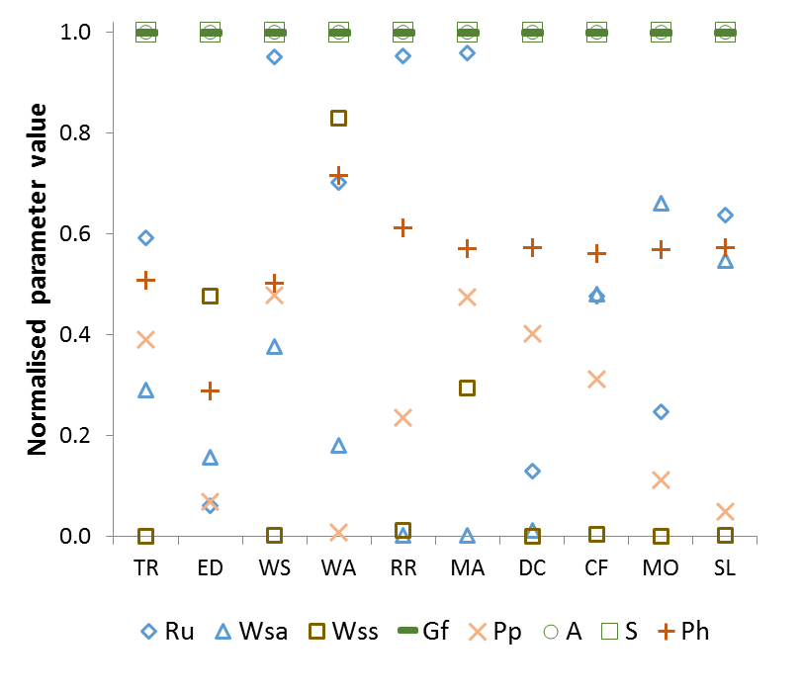
Figure 1.

A | B
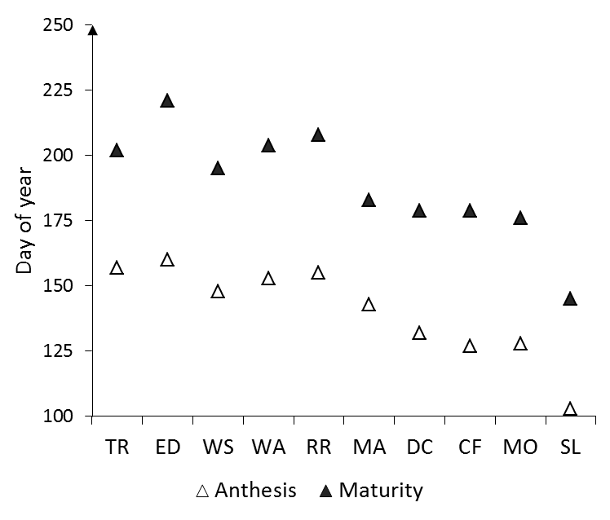 | 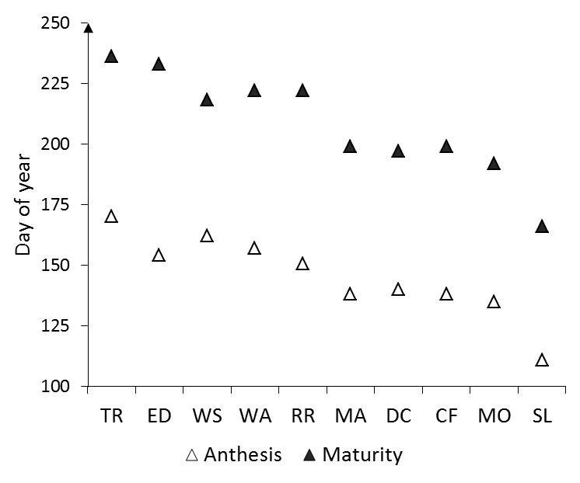
C | D
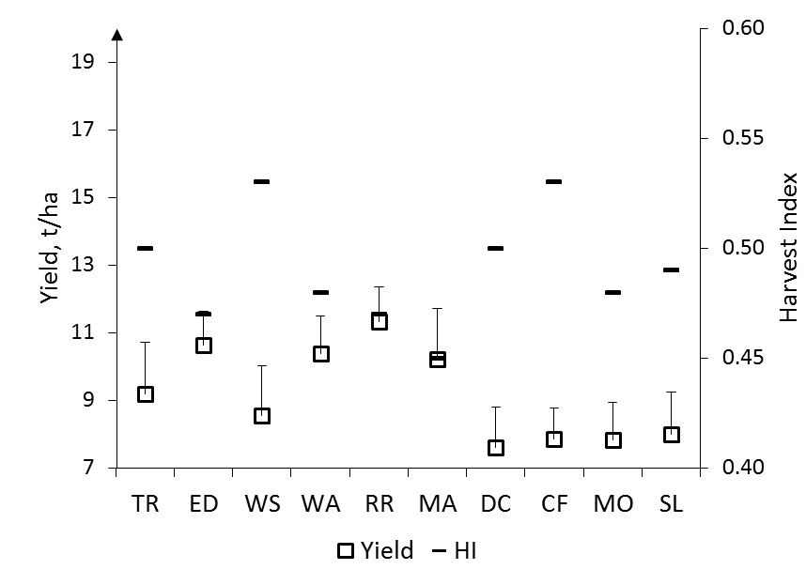 | 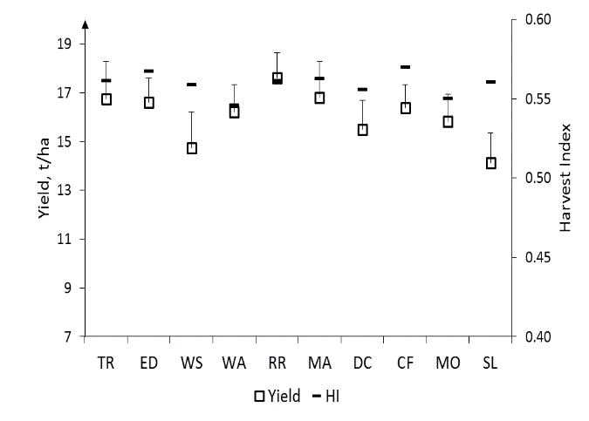

Figure 2.

A | B
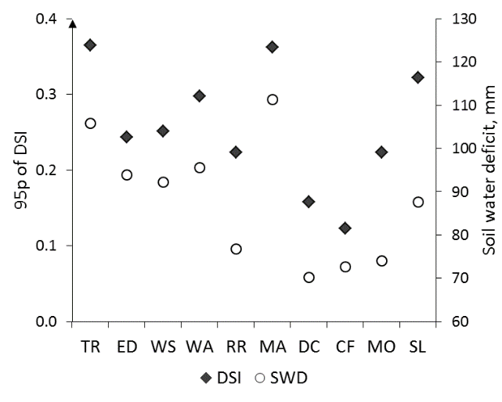 | 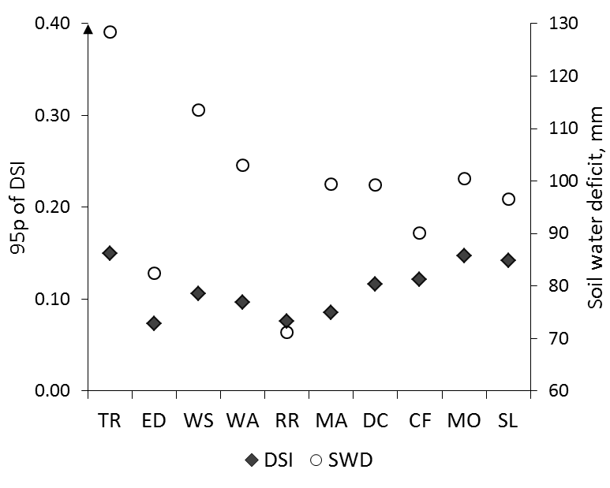
C | D
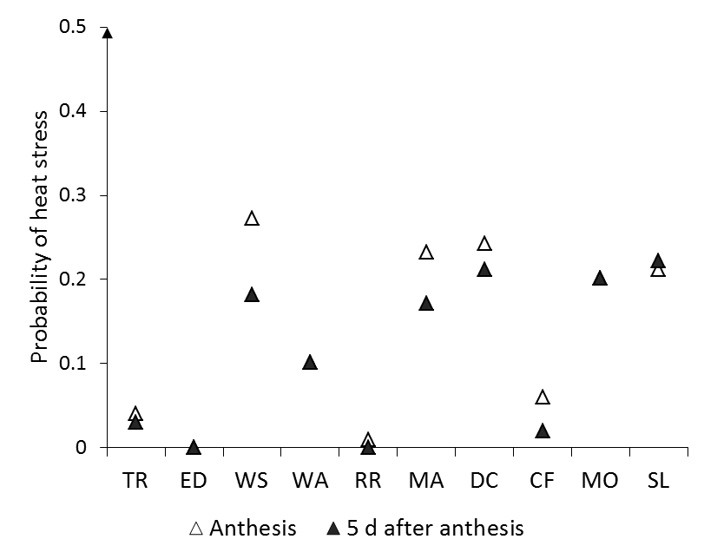 | 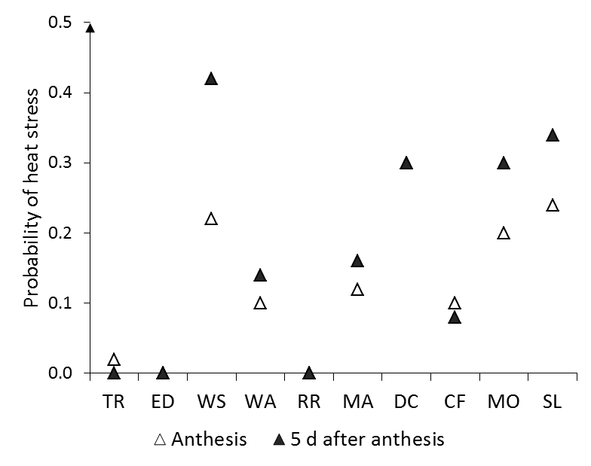

Figure 3.

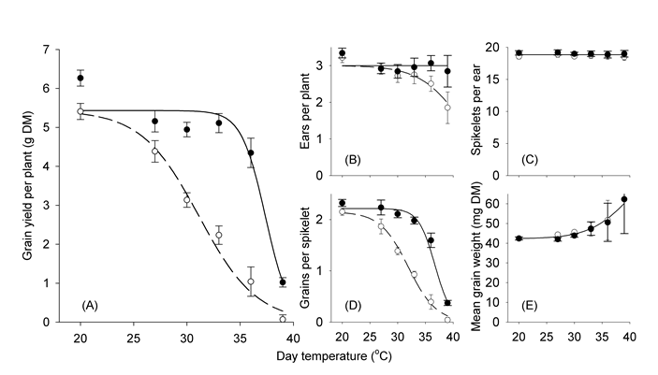
Figure 4.

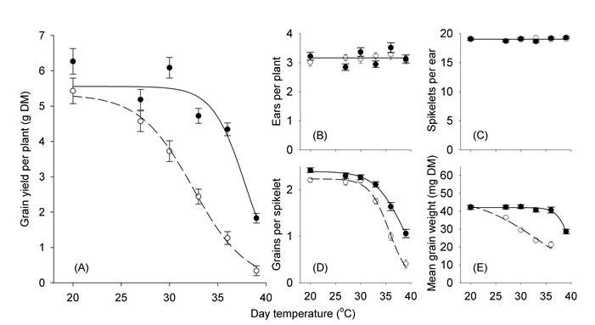
Figure 5.

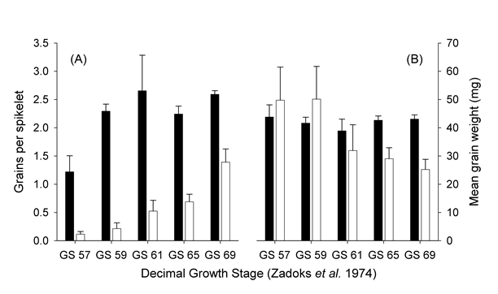
Figure. 6.

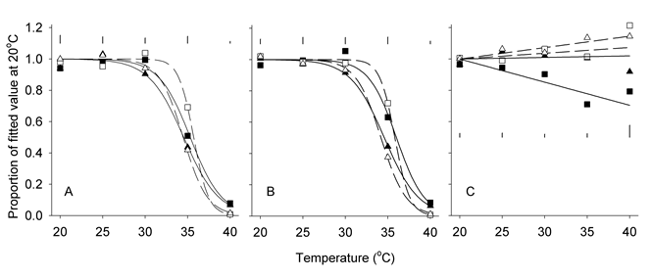
Figure 7.

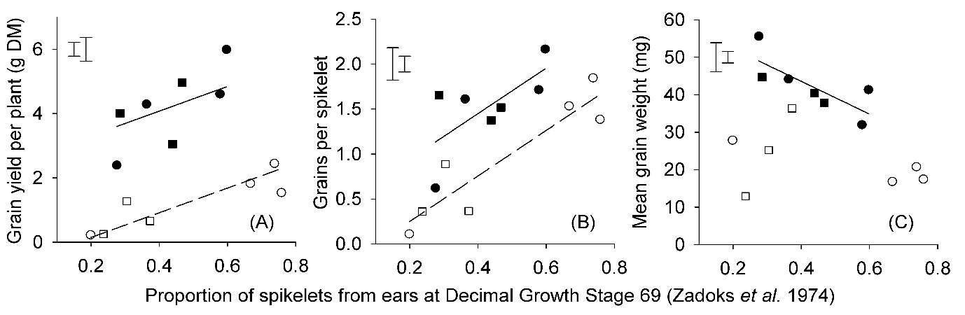
Figure 8.

ANNEX 1.

A schematic representation of a variant of EA-SA used for ideotype optimization is presented in Box 1. At every discrete step of optimization, t, the evolving state, a “parent”, is described as (x, v, σ_{v}, σ_{l} ), where x∈C⁹,v∈S⁹,σ_{v}∈[0,1],σ_{l}∈[0,1], C⁹ =[-1,1]⁹ and S⁹= {v∈C⁹, |v|=1}. x is a vector of cultivar parameters, and v is a vector controlling variation (“mutation”) for x with two scaling parameters σ_{v} and σ_{l}.
At each step t, a set of “offsprings” is created $\left\{{\left(x,v,σ_{v},σ_{l}\right)}^{i,j}\left(t\right), i<{k }_{v} j<{k }_{l}\right\}$ by mutating each parameter of a “parent” (x, v, σ_{v}, σ_{l})(t). The rules for mutation are specified in Box 1. Then, during selection, the “offspring” with the maximum of the “fitness” function F(x^{i,j}) is selected as a parent for the next step t+1, (x, v, σ_{v}, σ_{l})(t+1). The “fitness” function F(x) is defined as the mean yield calculated for a 100 years long climate scenario. The optimisation process stops when no further improvements of F(x) is possible, i.e. a local optimal is found for the set of cultivar parameters. Technical details and general conditions for convergence of an EA-SA algorithm could be found in (Semenov and Terkel, 2003).

EA-SA
{
Initialise $\left(x,v,σ_{v},σ_{l}\right)$(t=0)
Iterate (StoppingRule)
{
$\left\{{\left(x,v,σ_{v},σ_{l}\right)}^{i,j}\left(t\right), i<{k }_{v} j<{k }_{l}\right\}$= CreateOffsprings $\left(\left(x,v,σ_{v},σ_{l}\right)(t)\right)$
$\left(x,v,σ_{v},σ_{l}\right)\left(t+1\right)$ = Select$\left\{\left(x,v,σ_{v},σ_{l}\right)\left(t\right), {\left(x,v,σ_{v},σ_{l}\right)}^{i,j}\left(t\right) \right\}$
}
}
CreateOffsprings $\left(\left(x,v,σ_{l},σ_{v}\right)(t)\right)$
{
for(i<${k }_{v}$)
{
$$σ_{v}^{i}=mutate(σ_{v})$$
$$v^{i}=mutate\left(v,σ_{v}^{i}\right)$$
for(j<${k }_{l}$)
{
$$σ_{l}^{i,j}=mutate\left(σ_{l}\right)$$
$x^{i,j}=x+(σ_{l}^{i,j} ξ^{i,j})v^{i}$ where $ξ^{i,j}$ =rand(C¹)
${\left(x,v,σ_{l},σ_{v}\right)}^{i,j}\left(t\right)$ = $\left(x^{i,j},v^{i},σ_{v}^{i},σ_{l}^{i,j}\right)$
}
}
}
Select
{
if($F\left(x\right)≥F\left(x^{i,j}\right)$
{
$$\left(x,v,σ_{v},σ_{l}\right)\left(t+1\right)= \left(x,v^{l},σ_{v}^{l},σ_{l}^{l,m}\right), where F\left(x^{l,m}\right)=max\left\{F\left(x^{i,j}\right)\right\}$$
}
else
{
$$\left(x,v,σ_{v},σ_{l}\right)\left(t+1\right)= \left(x^{l,m},v^{l},σ_{v}^{l},σ_{l}^{l,m}\right), where F\left(x^{l,m}\right)=max\left\{F\left(x^{i,j}\right)\right\}$$
}
}
Mutate$(σ)$ { return $\left(σ e^{rand(C^{1})}\right)$}
Mutate$\left(v,σ_{v}^{i},\right)$ { return $\left( norm\left(v+σ_{v}^{i}rand(C^{n})\right)\right)$ }

Box 1. A schematic representation of a variant of EA-SA used for ideotype optimization.

